Site Risk Assessment

Client |  | Site address  Location on site
Site supervisor
Task | Brick/block laying

Start date |  | End date

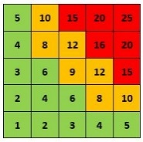
0-7 = Low risk. No action needed
8-14 = Medium risk. Adequate controls already in place
15-25 = High risk. Stop work/operation until controls are in place
Severity (S) x Probability (P) = Risk (R)
Severity (1= Negligible, 2= Slight, 3= Moderate, 4= Life changing, 5= Fatal)
Probability (1= Unlikely, 2= Possible, 3= Quite possible, 4= Likely, 5= Very likely)

